Iteration 4

Customer meeting date to demo this iteration:

We meet every Thursday morning at 11:00

User stories implemented in this iteration:

We do the administrator page, which includes histogram for reason No, and how many closed disease it has, export the closed data in tsv.

Feature: Add an administrator page

As a administrator

So that I can get the histogram for reason No, know how many closed disease it has, and export the closed data in tsv.

I want to get the closed items and supervise every user’s submission.

Heroku

<https://mighty-anchorage-26401.herokuapp.com>

Github

<https://github.com/marshalma/DiseaseDatasetCuration>

Pivottracker:

<https://www.pivotaltracker.com/n/projects/1565533>

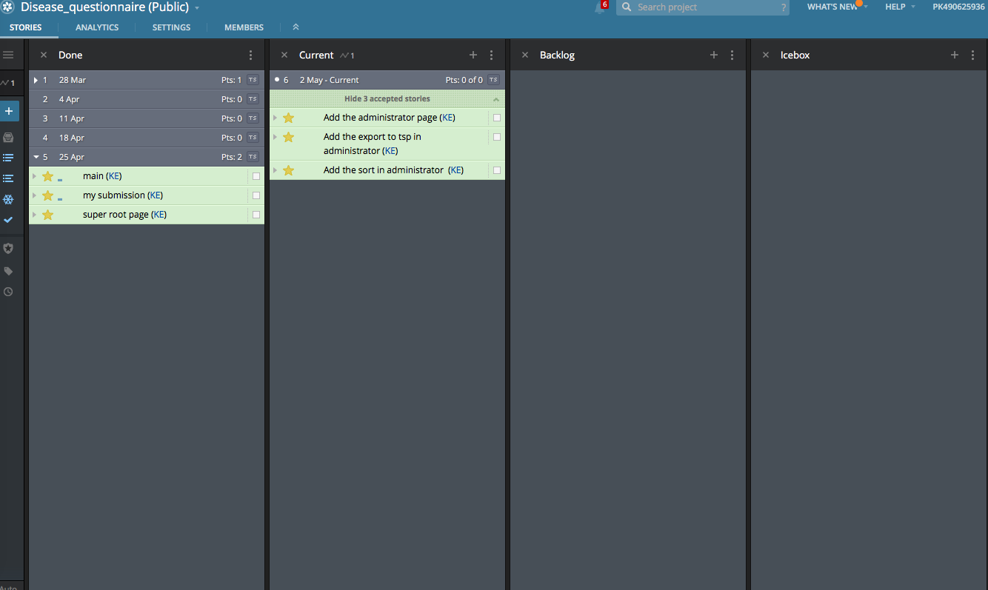

BDD

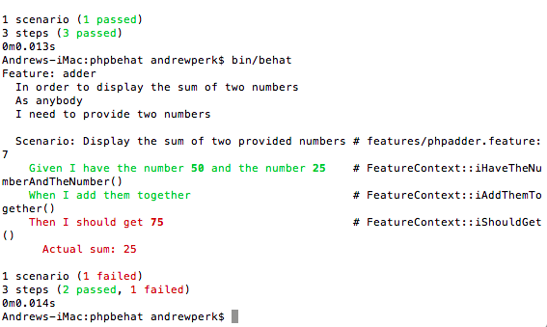

TDD

